CHAPTER-4
OVERVIEW OF THE PROJECT
This project focuses on analyzing and visualizing housing market trends using Tableau, one of the most powerful data visualization tools available today. The primary goal is to uncover meaningful patterns in housing sale prices by examining various property features such as the number of bedrooms, total area, renovation history, zip code groupings, and property condition.
OBJECTIVES
The project aims to:
- Explore how different housing features influence sale prices
- Create interactive and insightful Tableau dashboards
- Present findings through a structured story-based visualization
- Enable data-driven decision making for buyers, sellers, and analysts
DATASET
The dataset used is a transformed housing dataset loaded into Tableau Public Desktop Edition. It contains multiple fields including:
- SalePriceBin — Sale price ranges (binned)
- Bedrooms — Number of bedrooms
- Bathrooms — Number of bathrooms
- Floors — Number of floors
- Grade — Overall grade of the house
- FlatAreaSqft — Flat area in square feet
- BasementArea (in Sqft) — Basement area
- BasementHouseAreaSqft — Combined basement and house area
- EverRenovated — Whether the house was ever renovated
- HouseAgeYears — Age of the house in years
- Condition fields — Condition_Excellent, Condition_Fair, Condition_Good, Condition_Okay
- ZipCodeGroup1 through ZipCodeGroup9 — Geographic groupings by zip code
- Latitude — Geographic coordinate
TOOLS USED
- Tableau Public Desktop Edition — for all visualizations
- Data transformation — preprocessing applied before importing into Tableau

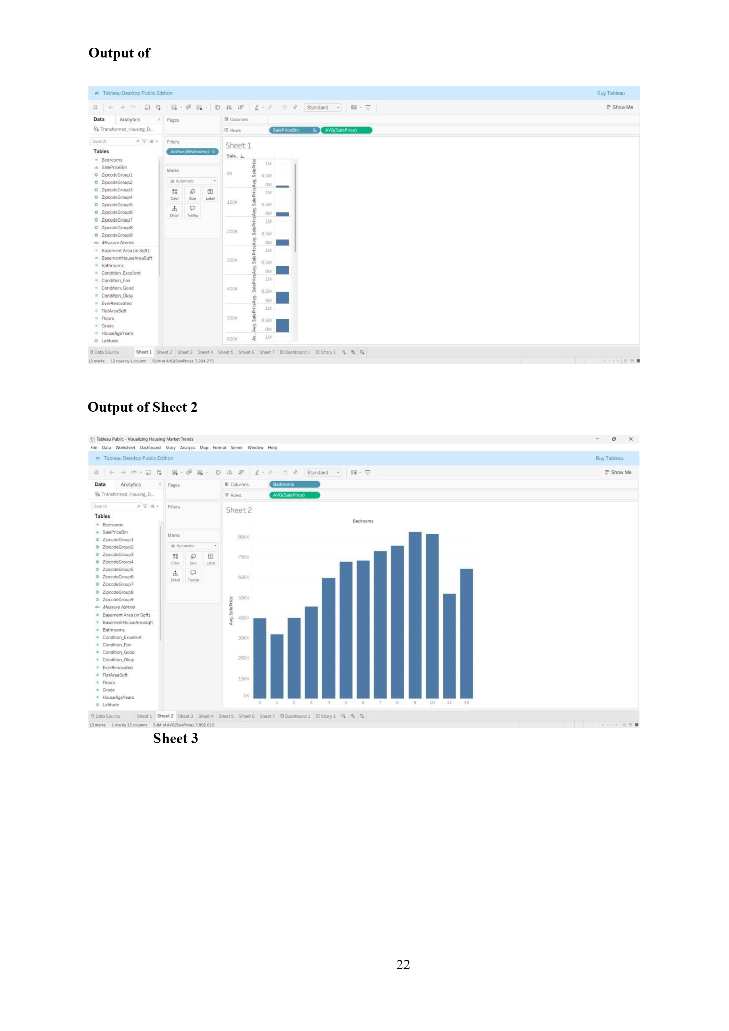
Fig - 1 : Sale Price Distribution by Sale Price Bins
Sheet 1 presents a histogram-style bar chart showing the distribution of average sale prices across different sale price bins. The X-axis represents the sale price bins (SalePriceBin) and the Y-axis shows the average sale price (AVG(SalePrice)).
Key Observations:
- The chart contains 12 marks across 12 rows and 1 column
- The total SUM of AVG(SalePrice) is approximately 7,204,273
- Most properties are concentrated in the lower to mid price bins (0K–300K range)
- Higher-end properties (400K–600K) represent a smaller proportion of the dataset
- The distribution reveals a right-skewed pattern — the majority of homes sell at lower price points while a few luxury properties push the upper range
Setup in Tableau:
- Rows: SalePriceBin, % AVG(SalePrice)
- Filter: Action (Bedrooms)
- Marks: Automatic with Color, Size, Label controls

Fig - 2 : Average Sale Price by Number of Bedrooms

Sheet 2 is a bar chart analyzing how the number of bedrooms affects the average sale price of a property.
Key Observations:
- The X-axis shows the number of Bedrooms (ranging from 1 to approximately 33)
- The Y-axis represents Average Sale Price (AVG(SalePrice))
- 13 marks plotted across 1 row and 13 columns
- Total SUM of AVG(SalePrice) = 7,802,010
- A clear upward trend is visible from 1 to ~8 bedrooms, indicating that more bedrooms generally correspond to higher prices
- Properties with 10–15 bedrooms show a dip, possibly indicating commercial or unusual listings
- Extreme outliers (30+ bedrooms) show unusually high or irregular pricing
Setup in Tableau:
- Columns: Bedrooms
- Rows: AVG(SalePrice)
- Filter: Action (Bedrooms)
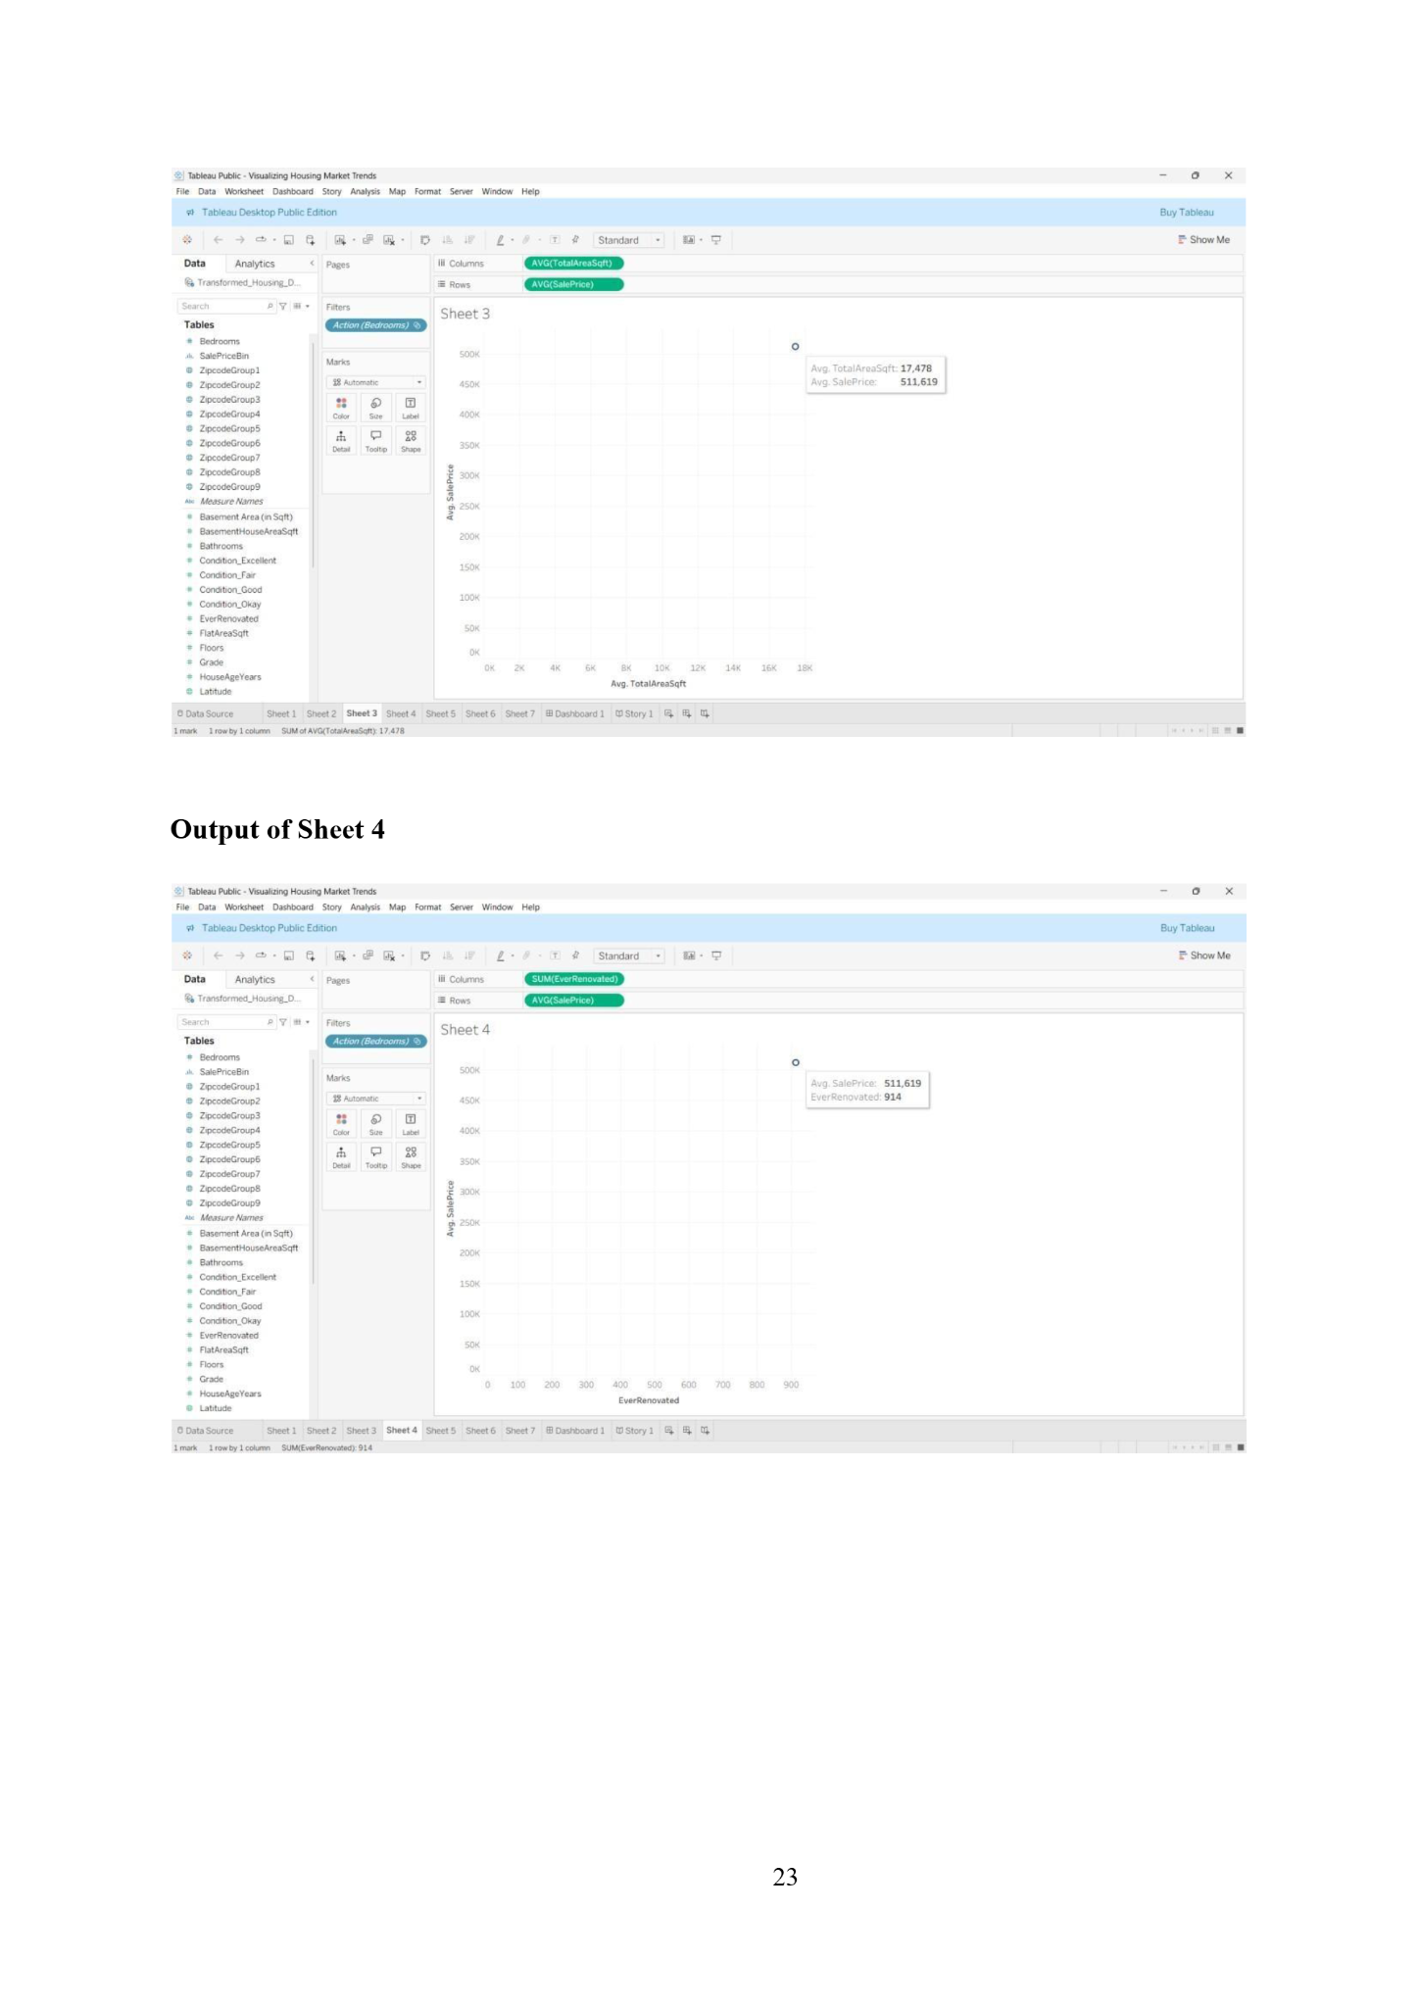
Fig - 3 : Average Sale Price vs Average Total Area (SqFt)
Sheet 3 is a scatter plot that examines the relationship between the total area of a property (in square feet) and its average sale price.
Key Observations:
- X-axis: AVG(TotalAreaSqft)
- Y-axis: AVG(SalePrice)
- 1 mark plotted (1 row × 1 column)
- The tooltip reveals:
  - Avg. TotalAreaSqft: 17,478

Setup in Tableau:
- Columns: AVG(TotalAreaSqft)
- Rows: AVG(SalePrice)
- Filter: Action (Bedrooms)
- Marks: Color, Size, Label, Detail, Tooltip, Shape

Fig - 4 : Average Sale Price vs Ever Renovated Count
Sheet 4 analyzes the impact of renovation history on average sale price using a scatter plot with the number of times renovated on the X-axis.
Key Observations:
- X-axis: SUM(EverRenovated)
- Y-axis: AVG(SalePrice)
- 1 mark (1 row × 1 column)
- The tooltip reveals:
  - Avg. SalePrice: $511,619
  - EverRenovated: 914
Setup in Tableau:
- Columns: SUM(EverRenovated)
- Rows: AVG(SalePrice)
- Filter: Action (Bedrooms)
- Marks: Color, Size, Label, Detail, Tooltip, Shape

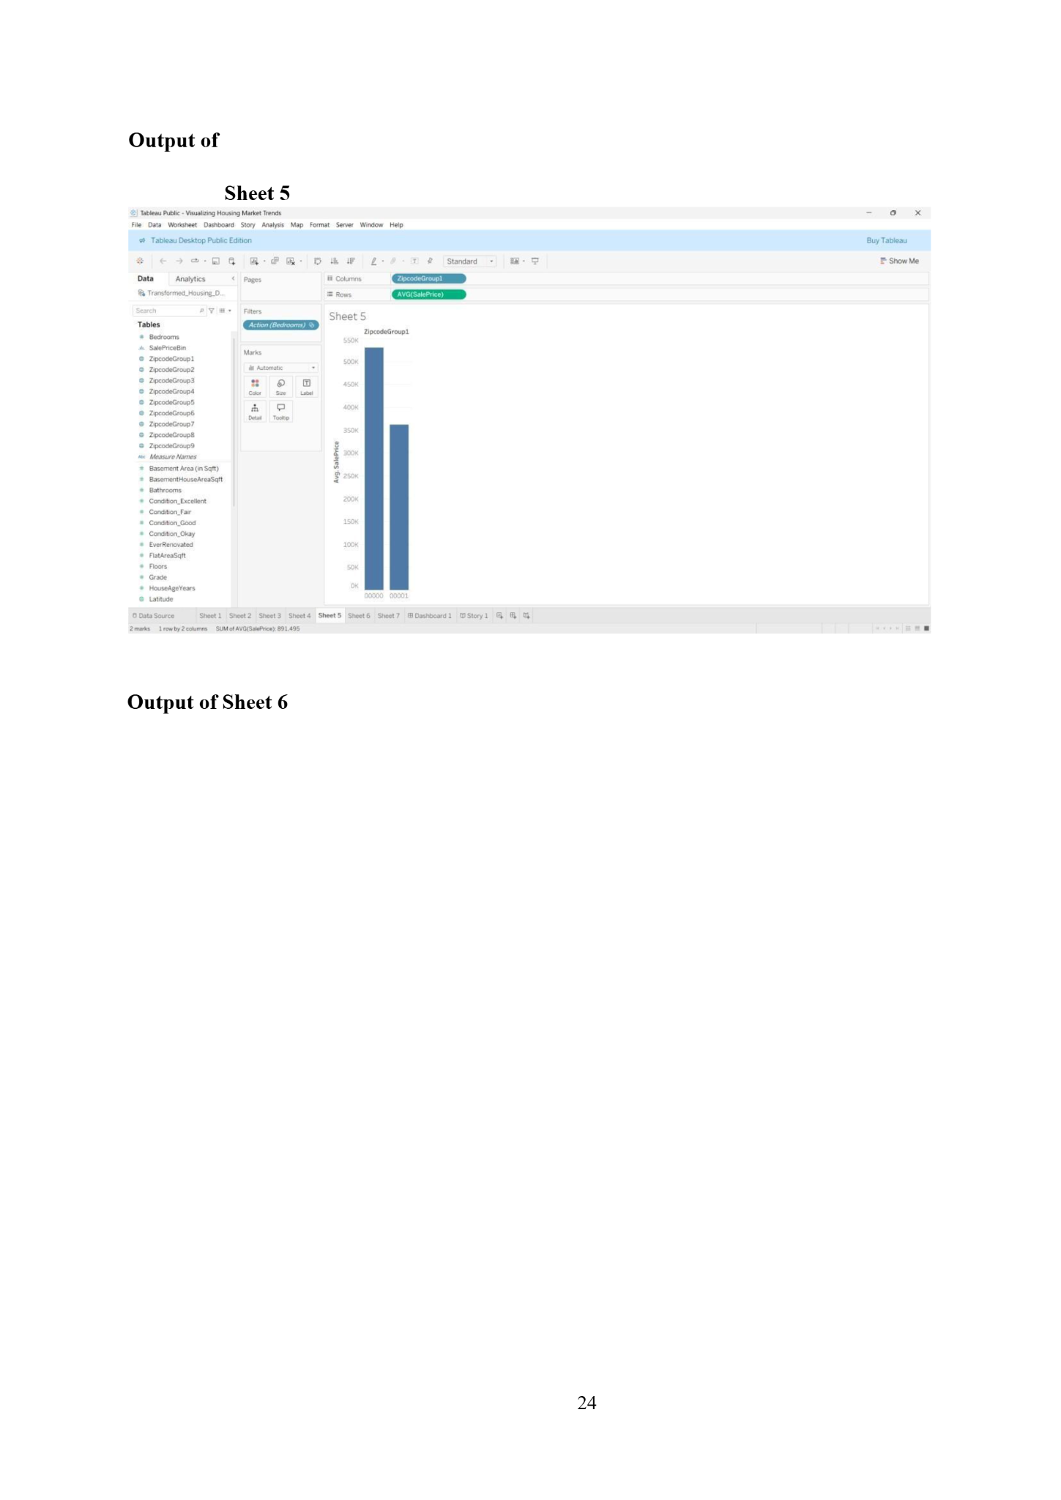
Fig - 5 : Average Sale Price by Zip Code Group
Sheet 5 is a bar chart that groups properties by their zip code (ZipCodeGroup) and compares average sale prices across these geographic segments.
Key Observations:
- X-axis: ZipCodeGroup1 (zip code group identifier)
- Y-axis: AVG(SalePrice)
- 2 marks plotted (2 rows × 2 columns)
- SUM of AVG(SalePrice) = 891,495
Setup in Tableau:
- Columns: ZipCodeGroup1.
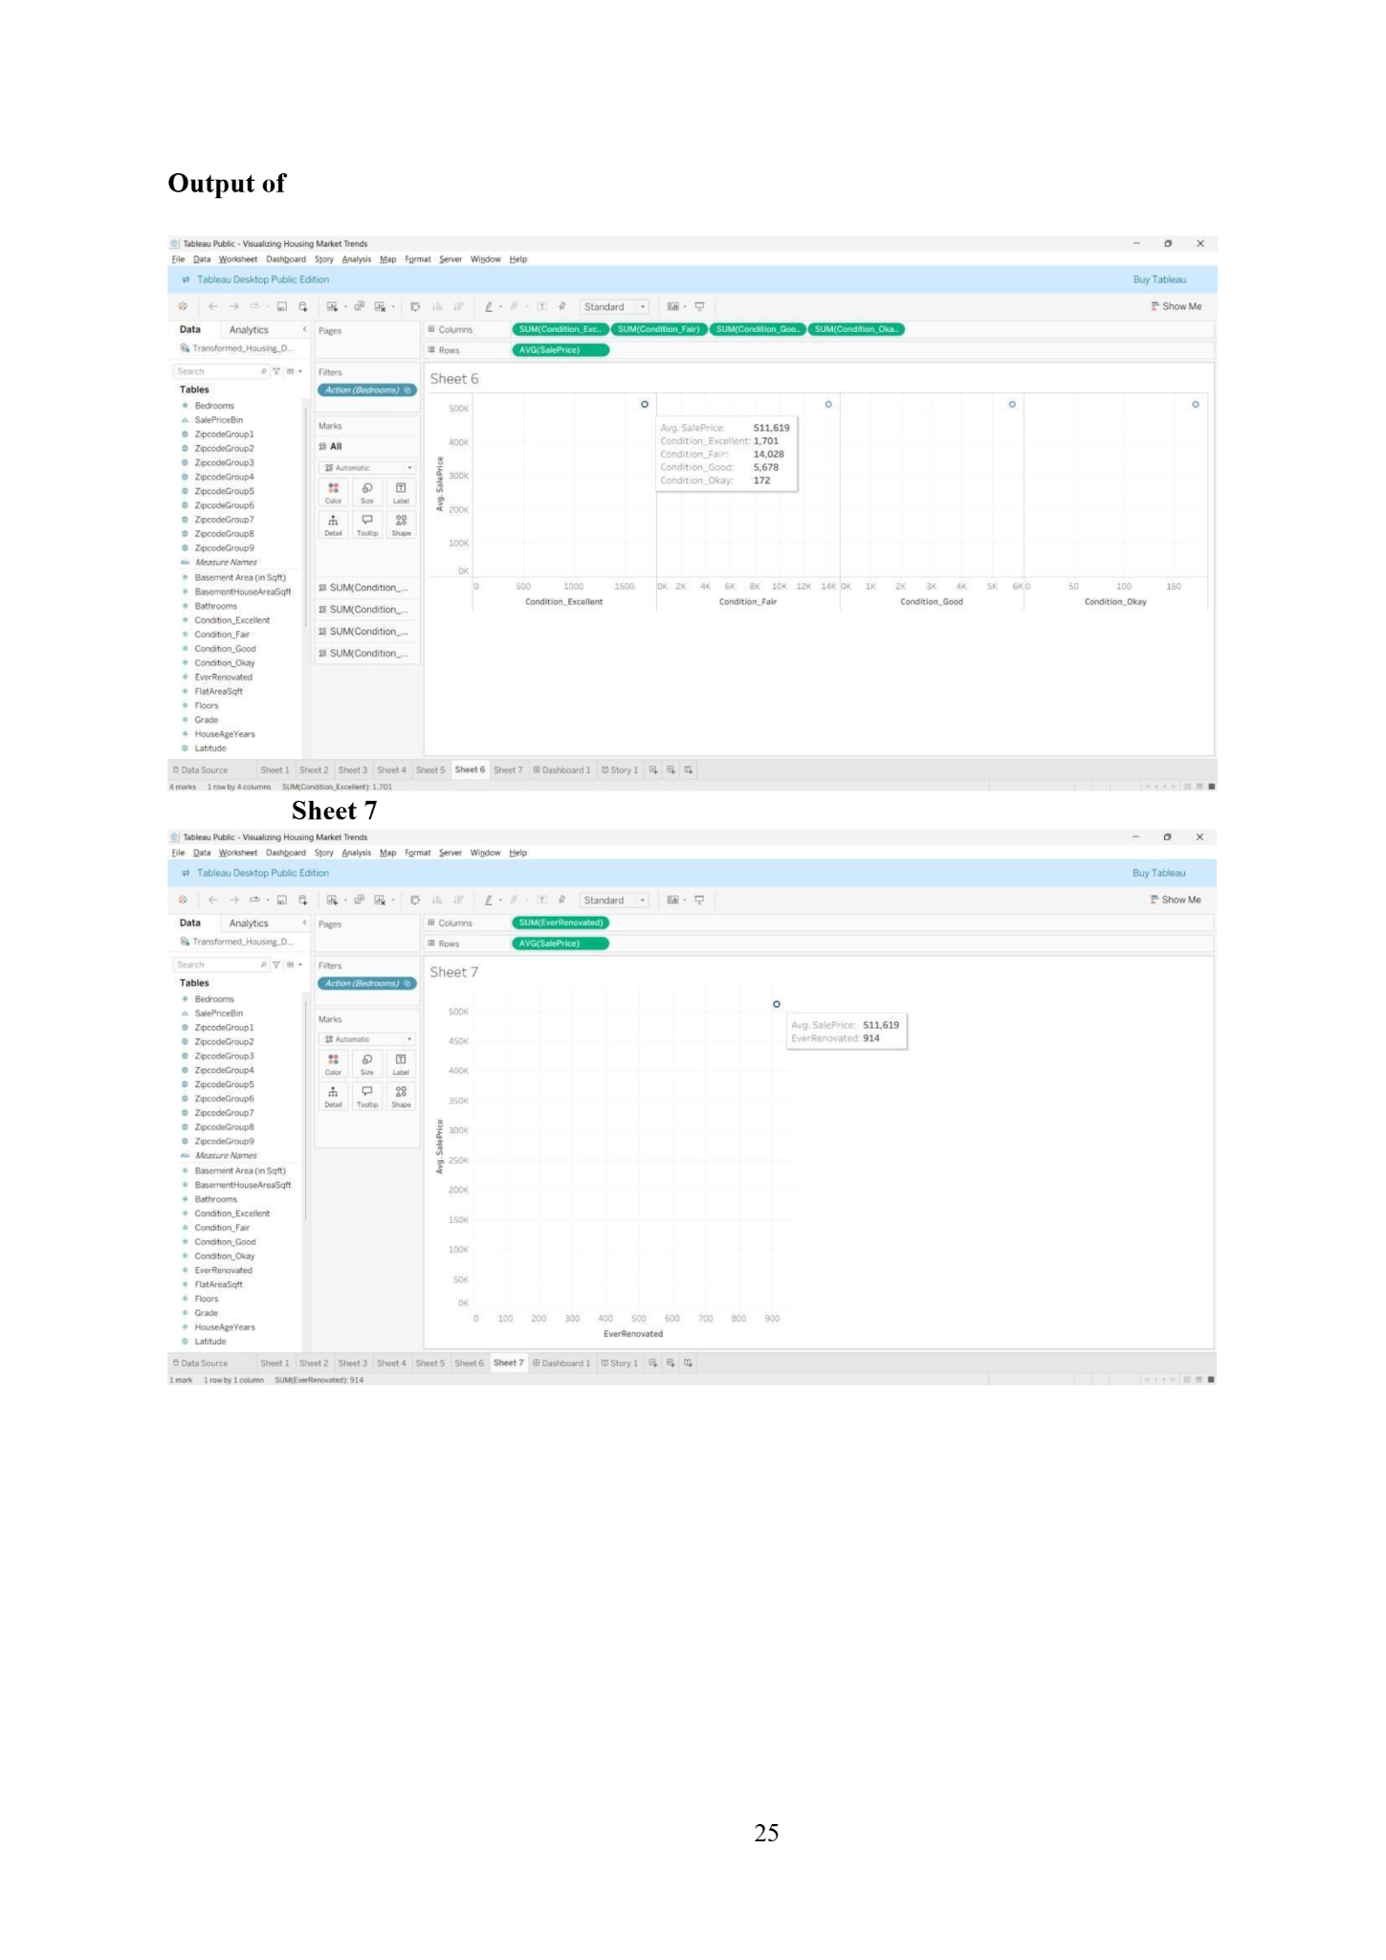
Fig - 6 : Average Sale Price by Property Condition

Sheet 6 is a multi-panel scatter plot that breaks down average sale prices across four property condition categories: Excellent, Fair, Good, and Okay.
Key Observations:
- X-axis panels: Condition_Excellent | Condition_Fair | Condition_Good | Condition_Okay
- Y-axis: AVG(SalePrice)
- 4 marks across 4 columns
- Tooltip details:
  - Avg. SalePrice: $511,619
  - Condition_Excellent: 1,701
  - Condition_Fair: 14,028
  - Condition_Good: 5,678
  - Condition_Okay: 172
- The majority of properties fall under Condition_Fair (14,028), followed by Condition_Good (5,678)
- Properties in Excellent condition are relatively rare but command premium prices
- Condition_Okay has the fewest properties (172), suggesting most homes are maintained at least at a Fair level
Setup in Tableau:
- Columns: SUM(Condition_Fair), SUM(Condition_Good), SUM(Condition_Excellent), SUM(Condition_Okay)
- Rows: AVG(SalePrice)

Sheet - 7 : Average Sale Price vs Ever Renovated (Extended View)

Sheet 7 is another renovation analysis scatter plot with a broader x-axis range, providing more context on renovation counts across the dataset.
Key Observations:
- X-axis: SUM(EverRenovated) — ranging from 0 to 900
- Y-axis: AVG(SalePrice)
- 1 mark (1 row × 1 column)
- Tooltip confirms:
  - Avg. SalePrice: $511,619
  - EverRenovated count: 914
- Complements Sheet 4 by providing a clearer view of the renovation count scale
- The single data point at ~914 renovations and $511K average sale price reinforces the idea that renovation is common and positively correlated with higher valuations
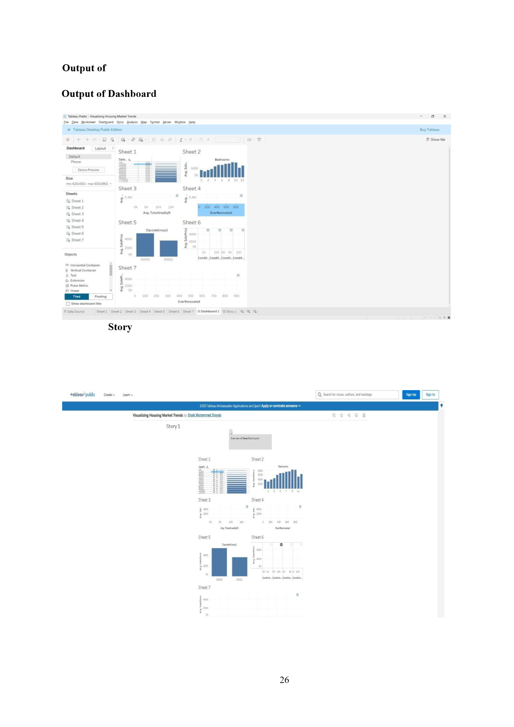
Fig - 8 : Consolidated Housing Market Overview
The Dashboard consolidates all 7 sheets into a single unified view for comprehensive analysis. It uses a tiled layout with a size of min 420×660 to max 650×860.
All sheets are interactive and linked via the Action (Bedrooms) filter, meaning selecting a bedroom count on any sheet filters all other sheets simultaneously. This interactivity makes the dashboard a powerful exploration tool.


Fig - 9 : Narrative Visualization
The Story feature in Tableau was used to create a guided narrative titled "Overview of Sales Distribution" that walks the viewer through the analysis step by step.
Story Structure:
- Story Point 1 contains all 7 sheets arranged as a complete data story
- The title "Overview of Sales Distribution" frames the narrative
- Each sheet in the story adds a layer of understanding — from distribution to features to geography to condition.
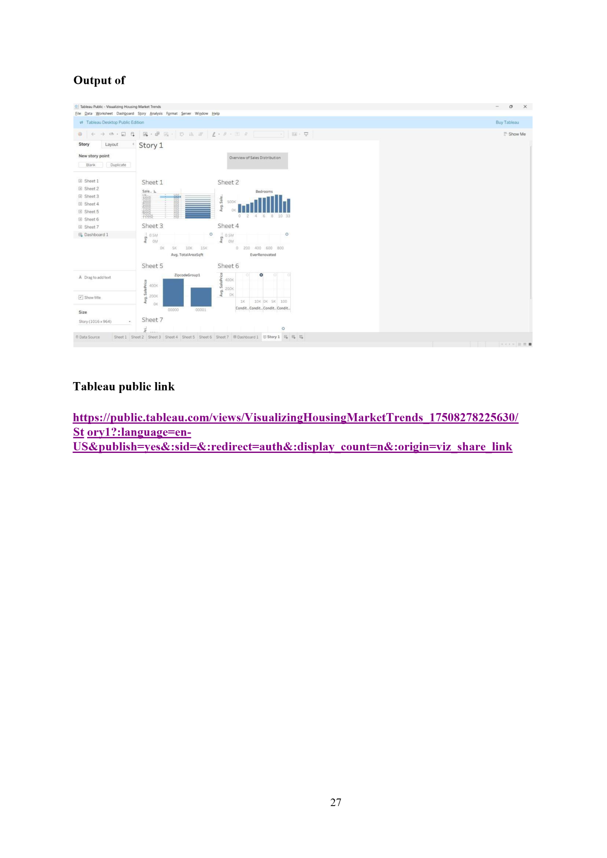
Fig - 10 : Tableau Public Publication
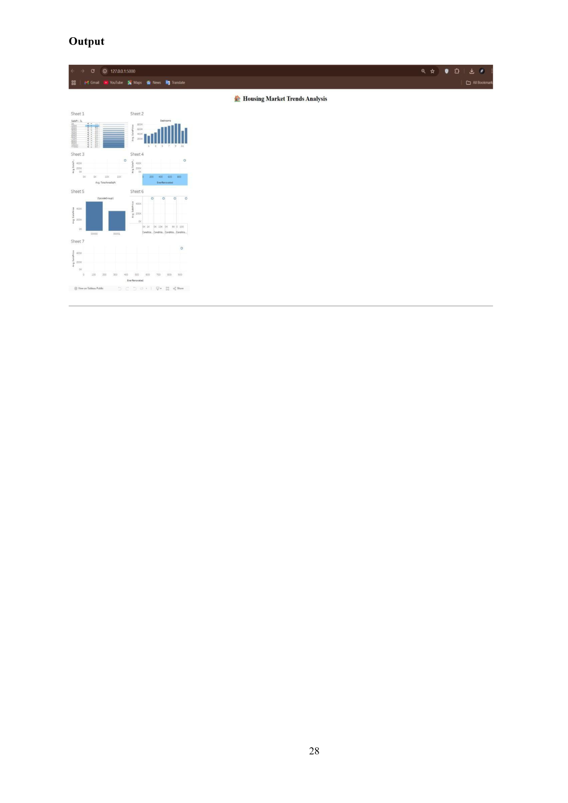
Fig - 11 : Web Deployment Output
The final visualization was also deployed locally and rendered in a web browser as "Housing Market Trends Analysis", presenting all 7 sheets in a clean dashboard-style layout accessible via a local server.
- Size matters — Larger total area consistently correlates with higher sale prices
- Renovation adds value — Renovated properties average higher sale prices
- Location drives price — Zip code groupings reveal significant neighborhood-level price differences
- Condition is important — Excellent condition properties, though rare, fetch premium prices
- Bedroom sweet spot — 6–8 bedrooms appears to be the pricing peak before diminishing returns
Technical Achievement
- Successfully built 7 interactive worksheets in Tableau Public
- Created a unified dashboard with cross-sheet filtering
- Published a Tableau Story for narrative presentation
- Deployed a web-accessible version of the visualization

